Wrestling Mat Light
The Light of CHAMPIONS

A small family run business with
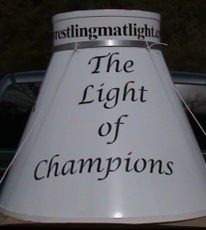
“A STRONG COMMITMENT ” to the sport of High School Wrestling.
CONTACT INFORMATION
Wrestling Mat Light
PO-BOX-12
Merrimack, NH 03054
OR
EMAIL-US-AT: len@wrestlingmatlight.com
Specw99@aol.com
Phone: (603)-377-7267
Cell: (603)-494-0692
“Please contact us for pricing and delivery information”

