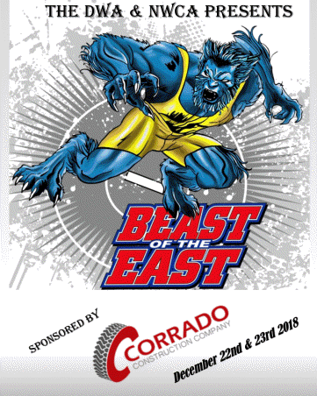
December 21st & 22nd, 2019
College Coaches Ticket Form
Name: _________________________________ _______ Head Coach
College: _________________________________ _____ Assistant Coach
Address: ___________________________________________________________
Contact Number: _________________ E-mail: ___________________________________
Number of Tickets Needed: _________ x $100.00 Total Amount Enclosed: $_________
Questions call Ann Vettori at 302-528-3207
Please complete this form and mail or email to the address below:
Mail to: Ann Vettori, 116 Tall Pines Road, Newark, DE 19713
Email to: f.vettori@verizon.net
Please make checks payable to: Delaware Wrestling Alliance or DWA
The DWA is a Non-Profit Organization 501-C3 Fed. Tax ID # - 51-0370928

